

**MATHEMATICS  
APPLICATIONS**

**Test 7 – Directed Graphs and Networks**

**Chapter 9**

**Semester 2 2017**

**Calculator Assumed**

Time allowed

Working time for this section: 55 minutes

Marks available: 53 marks

## Material required/recommended for this section

##### To be provided by the supervisor

This Question/Answer booklet

Formula sheet

##### To be provided by the candidate

Standard items: pens, pencils, pencil sharpener, eraser, correction fluid, ruler, highlighters

Special items: drawing instruments, templates, notes on one unfolded sheet of A4 paper, and up to three calculators satisfying the conditions set by the Curriculum Council for this course.

## Important note to candidates

No other items may be used in this section of the examination. It is **your** responsibility to ensure that you do not have any unauthorised notes or other items of a non-personal nature in the examination room. If you have any unauthorised material with you, hand it to the supervisor **before** reading any further.

1. (13 marks)   
   The map below shows 6 buildings A, B, C, D, E and F which are connected by one-way streets. The arrows show the direction of flow of traffic. The capacity of each street, in number of vehicles per minute, is given in the numbers alongside the edges.

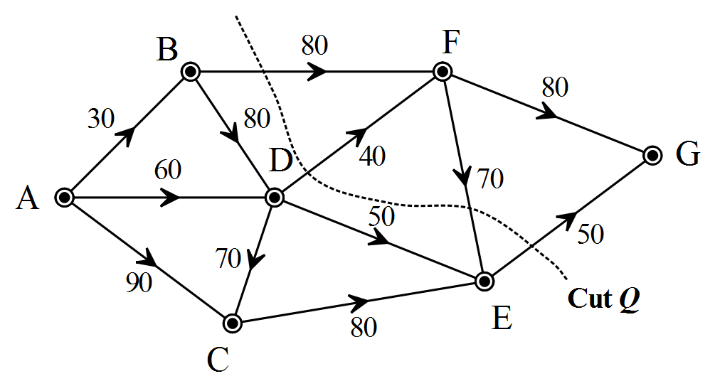

* 1. Determine the capacity of the cut Q drawn on the diagram above. [1]
  2. In the diagram above, draw a cut labeled R with a capacity of 300 vehicles per minute. [2]
  3. Determine the maximum flow for this traffic network.   
     Show clearly how you obtained your answer. [3]
  4. In the diagram below, draw the cut that corresponds to the maximum flow. [2]

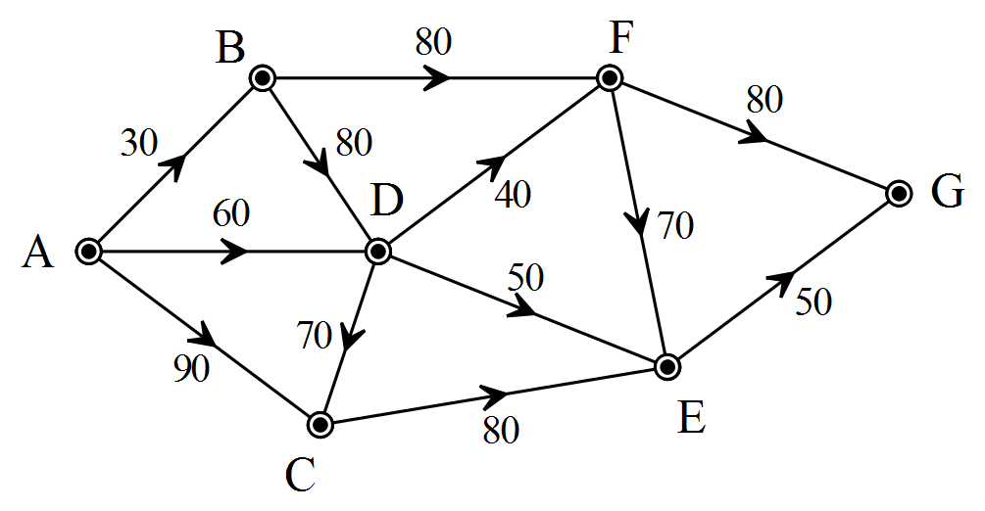

* 1. In the diagram below, indicate the unused capacity when the maximum flow is achieved. [2]

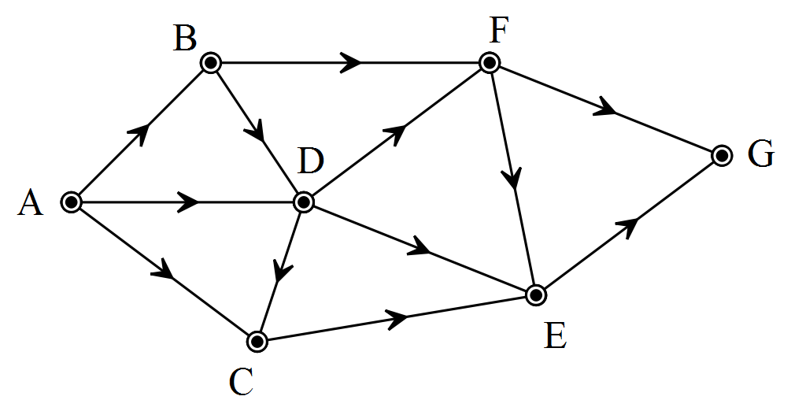

* 1. The Mayor of the city wishes to improve the maximum flow so that it matches the flow from the source. How would you achieve this if you were allowed to change the traffic flow of one of these streets and improve the capacity of another one of these streets? [3]

1. (11 marks)

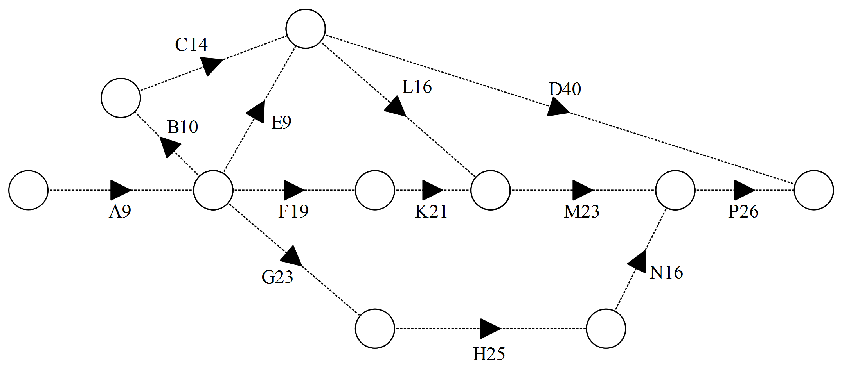

For the project network above, the minimum times required to complete the various activities are recorded in days.

* 1. Find the minimum completion time and the corresponding critical path(s). Working should be shown in the way of EST’s and LST’s. [4]
  2. By how many days can Activity E be delayed without affecting the minimum completion time? [1]
  3. Activity H can now be completed in 22 days. Determine the effect this will have on the minimum completion time and critical path. [3]
  4. After some reorganisation, it is now possible to commence Activity C immediately after the completion of Activity A. Discuss the effect of this reorganisation on the minimum completion time and the critical path. [3]

1. (6 marks)   
   A transport company has packages to collect from three locations A, B and C, and has four vehicles that are available. The graph below shows the current distances of each vehicle from the locations in kilometres.

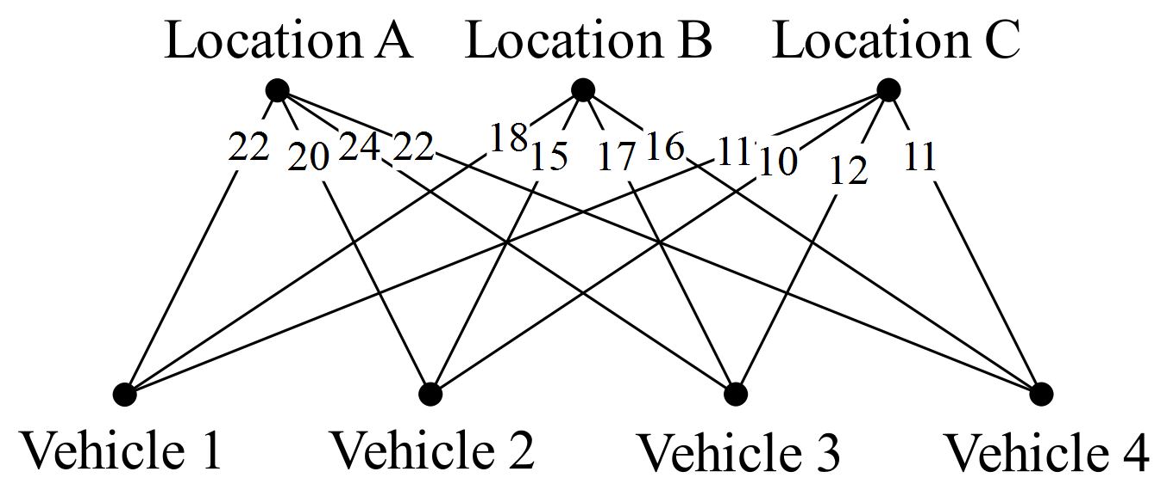

1. Represent the information in the graph as a 4 x 4 matrix. [1]
2. Show use of the Hungarian algorithm to determine which vehicle should collect which package in order that the total distance travelled by the vehicles is a minimum and state what this minimum distance is. [4]
3. If the initial distance of vehicle 3 from location A was reduced by 2 km, explain what effect, if any, this would have on your answer to (b). [1]
4. (7 marks)  
   In a chocolate factory, boxes of chocolates are transported along a series of conveyor belts from the production area A to the loading area J. The number on each arc is the number of boxes of chocolates that can be moved along the conveyor belt each minute.

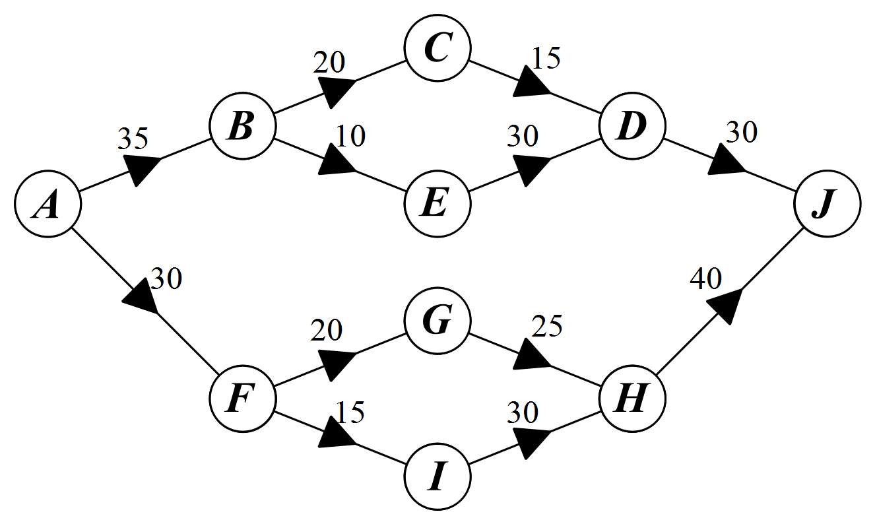

* 1. Find the maximum flow of chocolates, in boxes per minute, which can be moved through the factory. [3]
  2. The factory wants to increase the capacity of its conveyor belts.
     1. Explain why improving the capacity of IH will not increase the maximum flow of the system. [2]
     2. Suppose the capacity of BE is increased by 15 boxes per minute. By how much does this increase the maximum flow of the system? Explain [2]

1. (7 marks)  
   The accompanying table shows the number of new customers signed up per day by salespersons A, B, C and D at outlets located at shopping centres P, Q, R and S.

|  |  |  |  |  |  |
| --- | --- | --- | --- | --- | --- |
| Sales | P | Q | R | S |  |
| A | 16 | 12 | 18 | 6 |  |
| B | 17 | 17 | 20 | 7 |  |
| C | 13 | 14 | 19 | 8 |  |
| D | 16 | 15 | 19 | 6 |  |

Use the Hungarian algorithm to assign one salesperson to exactly one shopping centre maximising the total number of new customers signed up. Display your results in a bipartite graph then state all the optimum assignments and the corresponding sales made.   
  
Show each step of the process.

1. (9 marks)  
   The tasks involved in preparing the daily lunch in the school dining hall are shown in this precedence table.

|  |  |  |
| --- | --- | --- |
| Task | Time (minutes) | Immediate Predecessors |
| A | 30 | - |
| B | 20 | - |
| C | 40 | - |
| D | 20 | A |
| E | 30 | A |
| F | 30 | D |
| G | 10 | E |
| H | 15 | B |
| I | 30 | C, H |
| J | 20 | F, G, I |

1. Complete the associated network below. [3]  
     
     
   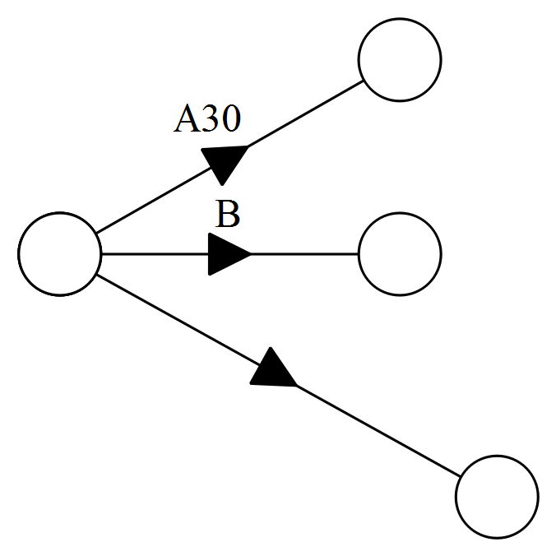
2. Find the minimum completion time for lunch preparation. Show evidence of working on the network above. [3]
3. State the critical path. [1]
4. The chef is looking to reduce the total preparation time. Find the maximum reduction in total preparation time that can be achieved by reducing the time required for task F. [2]

**End of Test**

Additional working space

Question number: ______